**Ginger Tea**

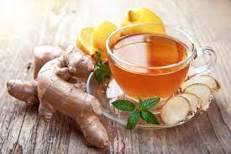

**INGREDIENTS**

½ cup fresh ginger root, cut into slices

4 cinnamon sticks

Sugar (white, granulated), sweetener, or honey, to taste

**METHOD**

Boil the cinnamon sticks in 8 cups of water until the water is lightly coloured. Remove the cinnamon.

Add the sliced ginger roots and boil for 5 minutes.

Remove the ginger and add sugar to taste.

Serve hot with cookies of your preference.